**Chapter 3**

**System Analysis**

**3.1 Study of Current System and Requirement of this System**

**Advantages**

* There are lots of scholarship available in this domain for obc - sc - st even open category also.
* There is a lot of chance available to get scholarship as compared to other scholarship website.

**Disadvantages**

* In this website there is only engineering related scholarships
* Also, there are less scholarship available

**3.2 Data Dictionary**

Table Name: contact

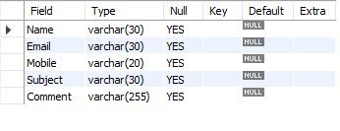

Table Name: form

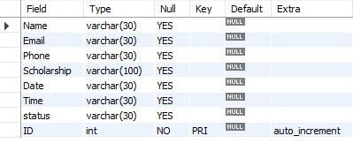

Table Name: scholarship

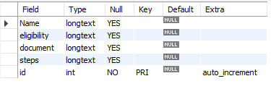

Table Name: signup

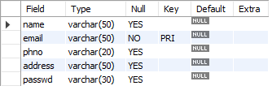

**3.3 Modules and Their Description of System**

**Clients Side Modules:**

1. **Login Page:** User first need to login. If user don’t have the account, then they can create by going to the signup page and if they have forgotten the password then they can also change it.
2. **Sign-Up Page**: If user don’t have an account, then they can create it by doing to create account part from login page.
3. **Forgot Password Page:** If by chance user has forgotten the password then they can change that by going to forgot password part from login page.
4. **Home Page:** In this home page information regarding our purpose, vision, Mission.
5. **Scholarship Page:** In Scholarship Page User can apply for which ever scholarships suit best to them, can read eligibility criteria, documentation, steps to apply our scholarships.
6. **Application Form Page:** User has to fill details regarding their name, email, phone number, scholarship name in order to apply for scholarships.
7. **Scholarship Details Page**: User can read all scholarship Details from this page.
8. **Contact-Us Page:** If User have any query, they can reach out the her by filling this form or they can also contact us through the given email id and given phone number.

1. **Dashboard:** User can see their scholarships in which they have applied and can also check the status of the scholarships.

**Admin Side Modules:**

1. **Login Page:** In order to go to the admin module admin first need to login with respective username and password.
2. **Home Page:** Admin can see user’s scholarship and can approve or decline the status.
3. **Add Scholarship Page:** In this page admin can add scholarship by filling Scholarship Name, Eligibility, Documents, Steps.
4. **Modify Scholarship Page:** In this page admin can modify all scholarship details based on the Scholarship Id given at the time of creation.
5. **View Scholarship Page:** From here admin can see all the Scholarship.
6. **Delete Scholarship Page:** In this page admin can delete the scholarship which is to be deleted.